**And Suddenly Jerra is a Bluebird**

Jerra was sitting in class trying hard to listen to the teacher but it was such a beautiful day outside and she had been stuck inside all weekend doing chores. The teacher was a substitute, since Mr. Joens was out for some reason.

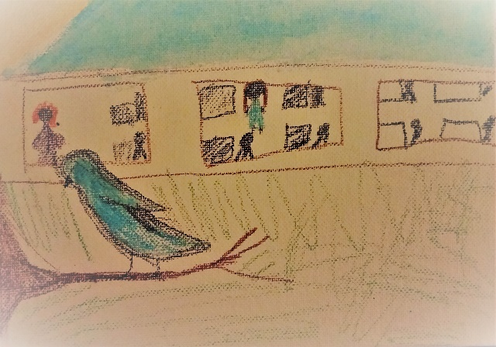And the substitute teacher, a lady with frizzy orange hair in a purple sweater was talking about cats. She had her cat in a travel box on the desk and, well, Jerra liked dogs better than cats, so learning about cats was not enough to hold her attention on such a beautiful day.

Also, and this is the most important part, there was a bluebird sitting on a branch outside the school window looking back at her. Jerra thought: Oh, how great it would be to be outside today on such a beautiful day!

Jerra also thought: Oh, how great it would be to be able to fly on such a beautiful day! And that was when she made her wish. But first, let’s see what the bluebird is thinking.

The bluebird had been watching the children inside the class for many months now. The bluebird wondered what they might be learning with all those books and desks and pencils and teachers. Even though it was such a beautiful day and even though, the bluebird could fly, it wondered what it would be like to be a child in school, able to learn so many new things every single day.

And that was when the bluebird made its wish. I think you know exactly what they wished for and exactly what happened next. You’d be correct if you thought that Jerra wished she could be the bluebird sitting on the branch outside.

You’d also be correct if you thought the bluebird wished it could be the student, Jerra, sitting on a desk inside the classroom learning from the orange-haired teacher in the purple sweater.

And since they both made their wish at the exact same time, Jerra suddenly became a bluebird a tiny little bird with wings! – perched on the branch outside. And the bluebird suddenly became Jerra – a full-sized human girl - with legs! – sitting at a desk inside the classroom.

Jerra was so excited, she…